Year | Event | Related Image
1963 | Dr. Paul Bedoukian creates the first commercially produced leaf alcohol ingredient – almost a decade before the founding of Bedoukian Research. | 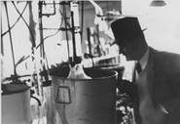
1972 | Bedoukian Research, Inc. is founded by Paul Bedoukian. | 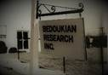
1973 | Bedoukian produces the Lactone of Cis Jasmone and Cis-3-hexenyl salicylate that goes into the popular Charlie perfume. | 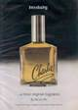
1975 | Dr. Robert Bedoukian, son of the founder of Bedoukian Research, joins the company. | 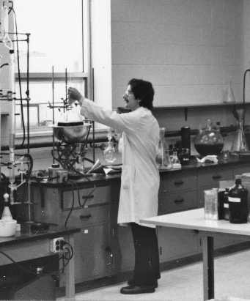
1976 | Bedoukian begins manufacturing its first insect pheromone: Gossyplure for Pink Bollworm, a cotton pest. These efforts ultimately lead to a new line of business under the name of BedoukianBio. | 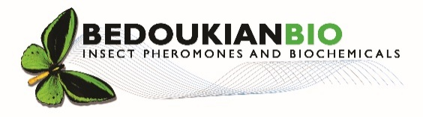
1986 | Bedoukian’s offices and shipping operations are moved to a new facility at 21 Finance Drive in Danbury, Connecticut. | 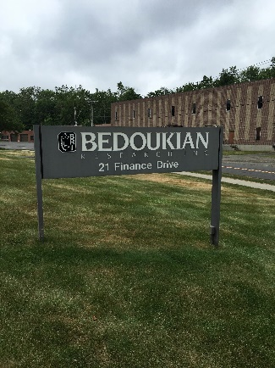
1986 | Robert Bedoukian assumes the position of President of Bedoukian Research, Inc. | 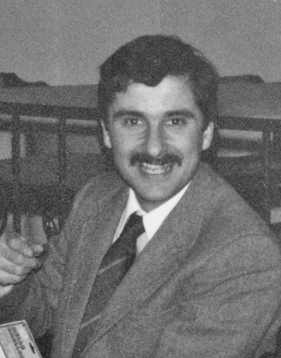
1989 | Robert Bedoukian joins RIFM Board. | 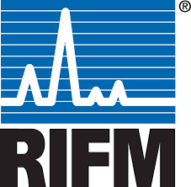
1992 | Robert Bedoukian founds the American Semiochemicals Association. | 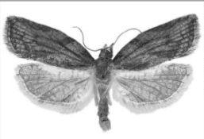
1994 | Bedoukian’s first Million Dollar Month! | 
1994 | A compendium of fifty years of articles written by Paul Bedoukian is published in hardcover as “Perfumery and Flavoring Materials”. | 
1995 | Robert Bedoukian joins the board of the Fragrance Materials Association (now FCA). | 
1995 | Bedoukian begins a three-year project to double the size of its production facility and capacity in order to meet increased demand. | 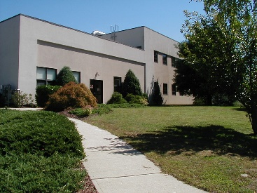
1999 | Bedoukian Research launches its industry leading website - Bedoukian.com. | 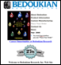
2002 | Paul Bedoukian receives FMA Lifetime Achievement Award (posthumously). | 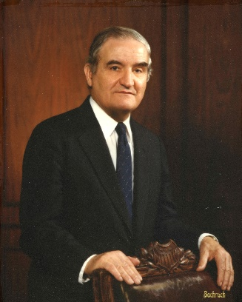
2006 | The third generation of Bedoukians (Matt and David) officially join the company. | 
2015 | Robert Bedoukian is presented with the Eric Bruell Distinguished Service Award from IFRA for his contributions to the fragrance industry. | 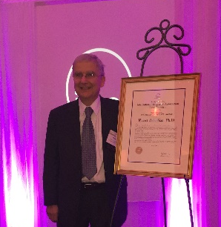
2018 | Bedoukian Research opens its new distribution center and corporate offices at 6 Commerce Drive in Danbury. | 
2020 | Bedoukian Research receives Outstanding Corporation Award in Connecticut from the Association of Fundraising Professionals. | 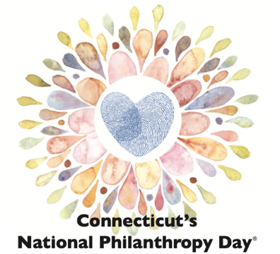
2020 | Bedoukian’s 2nd employee retires after 49 years with the company. | 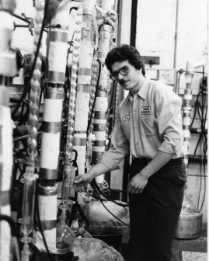
2021 | Bedoukian Receives EcoVadis silver award for its sustainability efforts. | 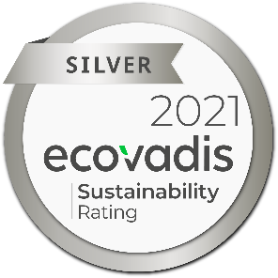
2022 | Bedoukian celebrates its 50th year in business with new logos, a new website, new lines of businesses as well as a continued commitment to offer quality products and exceptional service. | 

